Chara: Occurrence, Features and Reproduction

Occurrence of Chara:
Chara is represented by about 188 species, out of which 30 species are found in India. It is commonly known as “stonewort”. The plant body of Chara is encrusted with calcium and magnesium carbonate especially on the plants growing in heavy water.
Thus the plants become strengthened and called stoneworts. Generally they grow in fresh water of ponds, lakes, tanks etc. in submerged condition. Some species like C. tragilis grows in hot spring, whereas C. baltica grows in brackish water.

Plant Body of Chara:
ADVERTISEMENTS:
Chara is a macroscopic, multicellular, profusely branched thalloid plant body, generally attains a height of about 20-30 cm (rarely about 1 meter). It is differentiated into rhizoid and main axis (Fig. 3.91 A).
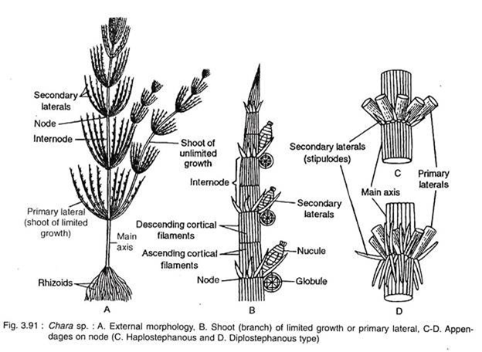
A. Rhizoid:
The rhizoids are thread-like, white, multicellular, uniseriate and branched. It is an elongated branched structure having oblique septa. They are developed either from the base of the plant body or from peripheral cells of lower nodes of the main axis.
B. Main Axis:
It is an erect, long, branched epigeal portion of the plant body, which is differentiated into internodes and nodes.
(i) Internodes:
Generally it consists of two types of cells: i. axial cell or internodal cell, and ii. cortical cells.
i. Axial Cell:
It consists of an elongated central cylindrical cell (Fig. 3.94):
ii. Cortical Cells:
These are elongated but much smaller in diameter than axial cell and ensheathed or corticated as a layer on the outer surface of axial cell (Fig. 3.94). They originate from the node. After originating from the node, 50% of the cortical cells grow upward as the ascending filaments and the rest 50% grow downward as the descending filaments (Fig. 3.91 B).
The ascending filaments cover the lower half and descending filaments cover the upper half of the axial cell. Cortication is not common in all the species.
Depending on the presence or absence of cortex, the species of Chara are divided into two types: Corticate (e.g., C. fragilis, C, zeylanica, C. hatei etc) and Ecorticate (e.g., C. corallina, C. suc- cinata, C. wallichii, C. braunii etc.).
(ii) Node:
The node consists of two cells surrounded by 6-20 peripheral cells (Fig. 3.91 C, D). Three types of appendages are developed from each node.
These are:
ADVERTISEMENTS:
1. Branches of unlimited growth,
2. Branches of limited growth, and
3. Stipulodes.
1. Branches (Shoots) of Unlimited Growth:
:
They are also called axillary branches or long laterals (Fig. 3.91 A) and are developed from the older nodes. These branches are also differentiated into nodes and internodes like the main axis. Each node bears branchlets like the main axis.
2. Branches (Shoots) of Limited Growth:
They are also called primary laterals, branchlets or leaves (Fig. 3.91 B). About 6-16 branchlets develop in whorls around the node of main axis or branch of unlimited growth. It is also divided into 5-15 nodes and internodes. Each node develops some unicellular, hair-like secondary laterals. Sex organs are developed on lower nodes of each branchlet.
3. Stipulodes::
These are unicellular outgrowths developed from lower nodes of branchlets i.e., branches of limited growth. The number of stipufode at each node may be equal to the number of branchlets which is called unistipulate (C. nuda, C. brouni, C. coralline) or if double it is called bistipulate (C. contraria, C. tomentosa, C. baltica):
Depending on the arrangement of stipulodes species of Chara are divided into haplostephanous (i.e., stipules are arranged in single row) e.g., C. braunii, and diplostephanous (i.e., stipules are arranged in two rows) e.g., C. delica- tula (Fig. 3.91 C, D).

Cell Structure of Chara:
The nodal cells are short, uninucleate, with dense and granular cytoplasm and many discoid chloroplasts without pyrenoids. Small vacuoles may be present in the cytoplasm.
The internodal cells are long, with a large central vacuole, many nuclei and many discoid chloroplasts in the cytoplasm. The cytoplasm is differentiated into outer ectoplasm and inner endoplasm. The endoplasm shows streaming movement.
Growth:
Growth of Chara takes place by a dome- shaped apical cell. The cell undergoes repeated transverse divisions and form a row of three cells (Fig. 3.92A-B). The upper one remains as apical cell, middle biconcave one forms the nodal initial and the lower one forms the internodal initial.
ADVERTISEMENTS:
The nodal cell undergoes repeated vertical divisions and ultimately forms two central cells surrounded by 6-20 peripheral cells. Branches of limited growth are developed from the peripheral cells arranged in single row. The internodal initial does not divide further and elongates much more to form long internode (Fig. 3.92).
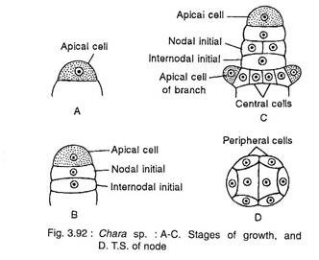

Important Features of Chara:
1. The plant body shows very much complexity in their structure.
2. They remain attached with the substratum by rhizoids.
3. The main axis is differentiated into nodes and internodes. Each node bears a number of branches of limited growth and sometimes single branches of unlimited growth.
4. The branches of limited, growth are also differentiated into nodes and internodes. Each node bears both the sex organs (Nucule i.e., female and globule i.e., male) and secondary laterals. Nucule is situated above the globule.
5. Reproduction is of two types: Vegetative and Sexual.
6. Vegetative reproduction takes place by means of specialised star-like, tuber-like and protonema-like structures.
7. Sexual reproduction is of oogamous type. The nucule is oval-shaped and very much protected, which contains one egg and globule is round and develops many antherozoids. Zygote is produced after sexual reproduction. It shows very much elaborate post-fertilisation changes.
8. During germination, zygote undergoes meiosis and gradually it forms the plant body of Chara.

Reproduction in Chara:
Chara reproduces by both vegetative and sexual means. Asexual reproduction is absent.
Vegetative Reproduction:
The vegetative reproduction takes place by the formation of following structures:
1. Bulbils:
These are small oval or spherical bodies developed on stem or root nodes. Bulbils are formed on root of C. aspera and stem of C. baltica. After detachment, they germinate and develop new plants (Fig. 3.93A, B).
2. Amorphous Bulbils:
These are small cells developed and aggregated at the node, called amorphous bulbils. They are found in C. fragilis, C. baltica etc. On being detached from the mother plant, they germinate and develop into new plants (Fig. 3.93C).
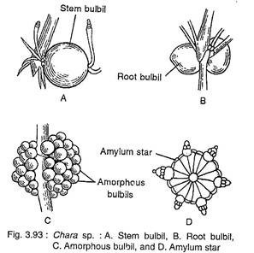
3. Amylum Stars:
These are multicellular aggregations of cells, looking like stars and the cells are densely filled with amylum starch; thus they are called amylum stars. The amylum stars are developed at the nodal cells of the basal region e.g., C. stelligera (Fig. 3.93D).
4. Secondary Protonema:
These are thread like structures developed from primary protonema or from the basal cell of the rhizoid. New plants are also developed from the secondary protonema.
Sexual Reproduction:
Sexual reproduction of Chara is an advanced oogamous type. The sex organs are macroscopic and large. The male sex organ is spherical and yellow to red in colour, called globule. The female sex organ is more or less oval and green in colour, called the nucule or oogonium.
They develop on the nodes of the branch of limited growth (i.e., primary lateral), intermingled with secondary laterals. Nucule is always situated singly above the globule (Fig. 3.91 B, 3.94).
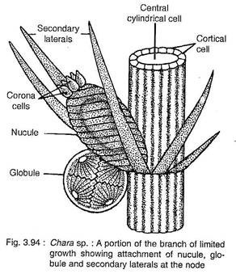
Most of the species are homothallic or monoecious (i.e., male and female sex organs develop on the same plant), but some are heterothallic or dioecious (e.g., C. wallichii).
Structure of Mature Globule:
Mature globules are spherical in shape and yellow to red in colour (Fig. 3.95C). Each globule consists of eight curved plates, situated towards the outer side, which are the shield cells.
From the inner side of the each shield cell, a centrally placed rod shaped structure is developed, called the manubrium. At the distal end of each manubrium one or more globose cells developed are called primary capitula. Each primary capitulum develops two or more secondary capitula.
Finally each secondary capitulum develops 2-4 long antheridial- filaments (Fig. 3.95H, I). Each antheridial filament has 25-250 cells and each cell i.e., antheridium (Fig. 3.95J, K) forms a biflagellate, coiled and uninucleate antherozoid (Fig. 3.95L). Thus a globule can develop as much as 20,000 to 50,000 antherozoids.
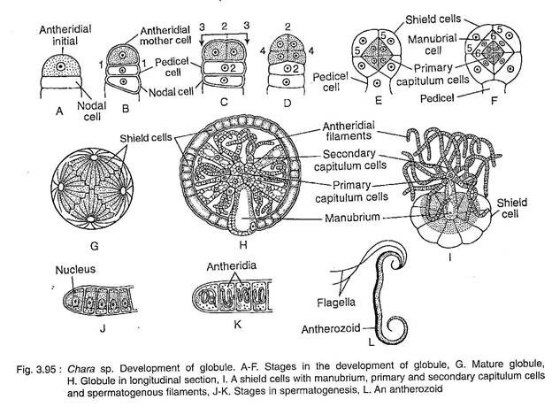
Structure of Mature Nucule or Oogonium:
The nucule of Chara is oval with a short stalk. Like globule it is also developed at the node of primary laterals just above the globule in homothallic species. It consists of centrally placed one central cell, one stalk and one large egg at the top (Fig. 3.96H). The entire structure is covered from the base by five spirally twisted tube cells except at the apex, where they form a crown made up of five corona cells (Fig. 3.94, 3.96H).
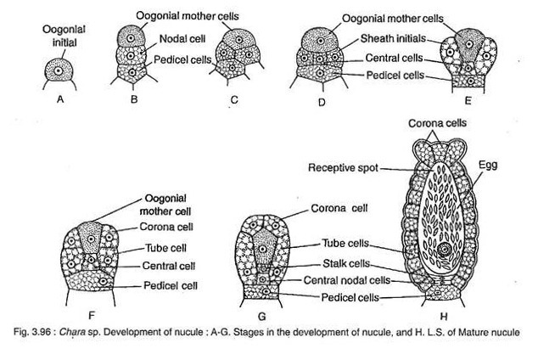
The jacket of nucule shows similarity with the neck cells of archegonium of Bryophyte.
Development of Sex Organ in Chara:
Development of globule (Fig. 3.95). The globule develops at the node of branches of limited growth. Single peripheral cell of each node functions as the antheridial initial (Fig. 3.95A). The antheridial initial first undergoes transverse division (1-1) to form 2 cells, of which the lower one is the pedicel cell, which forms the stalk.
The upper one is the antheridial mother cell. The antheridial mother cell, then undergoes two vertical divisions right angle to each other (2-2, 3-3) followed by one transverse division (4-4), thus an octant (8 celled stage) is formed.
Each cell of the octant stage then undergoes periclinal division (5-5) to form outer 8 and inner 8 cells. Either the outer or the inner cells then undergo another periclinal division (6-6), thus forming 3 layers of 8 cells each (Fig. 3.95B-F).
The outer 8 cells form the 8 shield cells, the middle 8 cells form the manubrium and the inner 8 cells form primary capitula. The primary capitula further divide and form two or more secondary capitula (Fig. 3.95H, I).
Each secondary capitulum further divides and forms 2-4 antheridial filaments consisting of 25 to 250 anthridial cells or antheridia, formed by repeated mitotic divisions. The protoplast of each antheridium metamorphoses into single biflagellate and coiled antherozoid (Fig. 3.95J, K, L).
Development of nucule (Fig. 3.96). The oogonial initial is developed from the peripheral nodal cell of the primary laterals (Fig. 3.96A). The oogonial initial cell undergoes two transverse divisions thus forming a 3 celled stage. The lowermost is the pedicel cell, middle one is nodal cell and uppermost one represents the oogonial mother cell (Fig. 3.96B). The pedicel cell remains undivided and forms stalk of the nucule.
The middle one undergoes several vertical divisions thus 5 sheath initials are formed which surround a central cell (Fig. 3.96C, D). The oogonial mother cell divides transversely and forms lower stalk cell and upper egg (Fig. 3.96G). The egg elongates further and forms an oval structure. The apical region of the egg develops the receptive spot. Large amount of oil and starch are deposited in the ovum.
The sheath initial elongates further and divides transversely into upper small cells, the corona cells which form a crown-like structure at the top of the oogonium and the lower five cells form the tube cells (Fig. 3.96F, G). The tube cells elongate and become spirally twisted in a clockwise direction outside the oogonium, giving protection to the egg (Fig. 3.94).
Fertilisation:
During fertilisation the tube cells just below the corona get separated slightly and form five narrow slits or openings. The antherozoids get entry through these slits (Fig. 3.96H). Out of many aggregated antherozoids towards the slits, only one comes near the receptive spot of the egg. On contact with the egg, it fuses and forms an oospore (2n).
Oospore:
It is hard, spherical to ellipsoidal in shape and of various colours like light yellow, brown, red or black. It is surrounded by four layered walls, of which the outer two are coloured and inner two are colourless.
Germination:
During germination the nucleus of oospore migrates towards the upper region (Fig. 3.97B). The nucleus then undergoes meiotic division to form 4 haploid nuclei (Fig. 3.97C). The oospore then divides into two unequal cells of which the upper lenticular cell contains one nucleus and lower large basal cell contains three nuclei (Fig. 3.97D). The nuclei of the basal cell gradually degenerate.
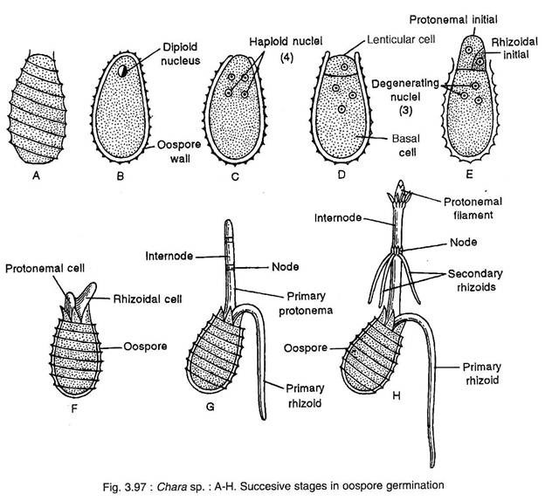
The lenticular cell projects out by rupturing the oospore wall and divides mitotically by an oblique longitudinal septum to form a larger protonemal initial and a small rhizoidal initial (Fig. 3.97E). Both the initials grow in opposite direction.
The protonemal initial is differentiated into nodes and internodes and form the upper part of the plant body, whereas the rhizoidal initial forms rhizoids (Fig. 3.97F, G, H). Secondary rhizoids may develop from the lower node of protonemal filament (Fig 3.97G)

Life Cycle of Chara:
Fig. 3.98 depicts the life cycle of Chara.
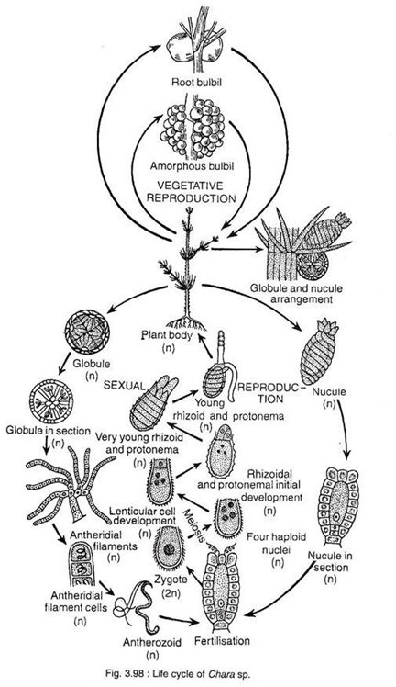

Taxonomic Status of Chara:
The systemic position of Chara has been, controversial for long time.
Fritsch (1935) placed Chara under the order Charales of the class Chlorophyceae based on:
i. Cellulosic nature of cell wall,
ii. Chlorophyll a and chlorophyll b as pho- tosynthetic pigments,
iii. Starch as reserve food,
iv. Number of flagella is two and of equal in length, and
v. Life cycle patterns are like the typical chlophycean members.
Later Smith (1938, 55) placed the order Charales in a separate class Charophyceae under the division Chlorophyta.
He placed Chara under the class Charophyceae based on the following characteristics:
i. Members are commonly known as stoneworts,
ii. Plant body is an erect branched thallus differentiated into a regular succession of nodes and internodes.
iii. Each node bears a whorl of branches of limited growth (the leaves), but branches capable of unlimited growth may arise axillary to the leaves,
iv. The members of the class are heavily calcified,
v. Female sexual reproductive structures are one-celled, surrounded by a sheath of sterile cells and are always borne upon the “leaves”.
vi. The antheridia are one-celled, united in uniseriate branched filaments surrounded by a common spherical envelope composed of eight cells.
Following Smith, Prescott (1965) also placed Chara under a separate class Charophyceae of the phylum Charophyta.
Later, Bold and Wynne (1978) placed Chara and other members under the division Charophyta. But instead of using the name “Charophycophyta” like other divisions, they named the division Charophyta.
The authors have not included the word phyco, in the division because of their “uncertainty that these plants, the stoneworts and brittleworts, are, in fact, algae”. So they have shown a doubt about these plants of being even the ‘algae’.
Chara shows marked advancement in the following characteristics:
i. The plant body consists of highly developed aerial portion differentiated into nodes and internodes and a prostrate portion like the root system,
ii. Elaborate sexual reproductive organs,
iii. Elongated biflagellate anthrozoids,
iv. Oogamous type of sexual reproductions, and
v. Elaborate post fertilization changes.
All the above features suggest that the status of Chara should be much higher than algae and closer to Bryophytes. According to Gramblast (1974) Charophyta occupies an isolated position between green algae and Bryophytes.
But there are certain characteristics which retain Chara where it is present.
These are:
i. Plant body is haploid,
ii. Though the nucule looks like a complex structure it is actually a simple unicellular structure like any other algae,
iii. The diploid stage is restricted in the zygote.
The difference between Chara and the members of green algae are strong enough to put Chara in a separate class under the division Chlorophyta. According to Church, Chara is a remnant of many probable evolutionary tendencies that have failed to attain land habit.
On the basis of morphological and cytological characters and oospore ornamentation, pattern Dr. P. chatterjee, Dr. Sam it Roy and Dr. Ruma Pal suggested that the genus Chara represents a specialised group (order Charales) and it should be placed under the class chlorophyceae.

Vaucheria: Occurrence, Reproduction and Life Cycle
Vaucheria: Occurrence, Reproduction and Life Cycle!

Vaucheria:
Systematic Position:
Class: Chlorophyceae
Order: Siphonales
Family: Vaucheriaceae
Genus : Vaucheria

Occurrence of Vaucheria:
Vaucheria is represented by 54 species of which about 19 species are found in India. Vaucheria is found mostly in fresh water but about six species are marine and some are terrestrial found on moist soil.
The terrestrial species like V. sessilis and V. terrestris form green mats on moist soil in shady places in green houses. V. amphibia is amphibous. V. jonesii was reported by Prescott (1938) in winter ice in U.S.A. The common Indian species of Vaucheria are V. amphibia, V. geminata, V. polysperma, V. sessilis and V. uncinata etc.

Thallus:
The thallus is made of long, cylindrical well branched filaments. The filament is aseptate, coenocytic structure. The thallus is attached to substratum by means of branched rhizoids or branched holdfast called the haptera. The thallus of V. mayyanadensis is differentiated in subterranean branched rhizoidal system and an erect aerial system. The filaments are rough, interwoven and appear as dark green felt like structure.
Some species like V. debaryana show calcium carbonate incrustations. The branching may be lateral or dichotomous. The filaments are non-septate, the protoplasm with many nuclei is continuous along the entire length of thallus thus the coenocytic Vaucheria thallus makes siphonaceous structure (Fig. 1A, B). The septa formation occurs only during reproduction or in Gongrosira condition or for sealing of an injury.
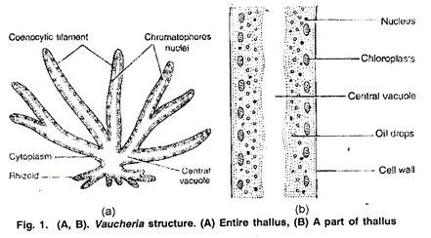
The thallus structure is differentiated into cell wall and protoplasm. The cell wall of thallus is thin, weak and non-elastic. The cell wall is made of two layers, the outer layer is pectic and the inner layer is cellulosic. Inner to the cell wall there is thick layer of protoplasm. A very large central vacuole filled with cell sap runs from one end of the filament to another forming a continuous canal or siphon.
In peripheral part of protoplasm are present a large number of small oval or disc shaped chloroplasts which lack pyrenoids (Fig. 1 B). Christensen (1952) reported presence of pyrenoids in chromatophores.
The chromatophores in Vaucheria contain pigments, chlorophyll a, chlorophyll e, carotenoids and an unknown xanthophyll. The pigments in Vaucheria are like those of Xanthophyceae as chlorophyll b the characteristic pigment of Chlorophyceae is absent.
Many small nuclei lie in the cytoplasm inner to the layer of chloroplasts. The arrangement of nuclei with respect to chloroplasts is reversed at the time of zoospore formation. The cytoplasm also contains other membrane bound cell organelle such as mitochondria, small vesicles and food is stored in form of oil. The growth of filament is apical, the filament increases in length by apical growth of all the branches.
Nature of Thallus:
The thallus of Vaucheria is branched, non-septate and multinucleate structure which appears like single large cell but Vaucheria cannot be considered as single cell. As in multicellular forms mitotic divisions take place increasing the number of nuclei. The apical growth takes place. Hence the aseptate coenocytic structure of Vaucheria should be considered as acellular coenocyte.

Reproduction in Vaucheria:
Reproduction in Vaucheria takes place by vegetative, asexual and sexual methods.

(i) Vegetative Reproduction in Vaucheria:
The vegetative reproduction takes place by fragmentation. The thallus can break into small fragments due to mechanical injury or insect bites etc. A septum develops at the place of breaking to seal the injury. The broken fragment develops thick wall and later on develops into Vaucheria thallus.

(ii) Asexual Reproduction in Vaucheria:
The asexual reproduction takes place by formation of zoospores, aplanospores and akinet
(a) By Zoospores:
The zoospores formation is the most common method of reproduction in aquatic species. In terrestrial species it takes place when the plants are flooded. Zoospore formation takes place in favourable seasons or can be induced if aquatic species are transferred from light to darkness or from running water to still water.
Zoospores are formed singly within elongated club shaped zoosporangium (Fig. 2A, B). The development of zoosporangium begins with a club shaped swelling at the tip of a side branch. A large number of nuclei and chloroplasts along with the cytoplasm move into it. A colourless protoplasmic region becomes visible at the base of cytoplasm and it is separated from rest of the cytoplasm of thallus.
Each separated protoplast secretes thin membrane and zoosporangium gets separated by a cross wall. Inside zoosporangium the vacuole decreases, the contents of sporangium become very dense and round off. The change takes place in relative position of chloroplasts and nuclei, the nuclei become peripheral and chloroplasts enter in inner layer of cytoplasm.
ADVERTISEMENTS:
The entire protoplasm of the zoosporangium contracts to form oval zoospore. Opposite to each nucleus two flagella are produced making zoospore a multi-flagellate structure. A terminal aperture develops in zoosporangium by gelatinization of wall. The zoospore is liberated through aperture in morning hours (Fig. 2 C, D).
Each zoospore is large yellow green, oval structure. It has a central vacuole which has cell sap and may be traversed by cytoplasmic strands. The protoplasm outer to vacuole has many nuclei towards the walls and chromatophores towards vacuoles. Two flagella arise opposite to each nucleus. This part of cytoplasm can be regarded equivalent to one zoospore.
Fritsch (1948) regarded this kind of zoospore as compound zoospore or synzoospore as a number of biflagellate zoospores have failed to separate from one another.
According to Greenwood, Manton and Clarke (1957) the flagella of a pair are heterokontic and whiplash type. The shorter flagellum of each pair is directed towards the anterior end of the zoospore. The flagellar bases are united together in pairs and are firmly attached to the tip of nuclei.
According to Greenwood et. al (1957), there is large anterior vacuole and small ones in the posterior region of the zoospores. Mitochondria are present in the peripheral layer of cytoplasm. Fat bodies and plastids are present in the cytoplasm. Chlorophyll has also been reported from the zoospores.
The zoospores swim in water for 5-15 minutes and germinate without undergoing any significant period of rest. The zoospores get attached to the substratum, withdraw flagella and secrete thin walls (Fig. 2 E, F). The chromatophores move outwards and nuclei inwards as in vegetative condition.
The two tube like outgrowths develop in opposite directions. One of the two outgrowths elongates, branches to form colourless lobed holdfast and the other outgrowth forms yellow-green tubular coenocytic filament (Fig. 2 G, H).
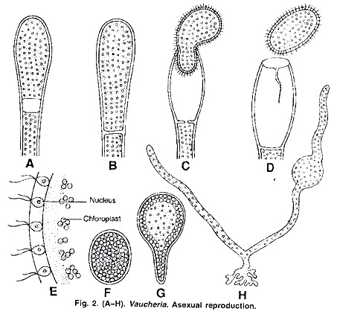
(b) By Aplanospores:
Aplanospores are commonly observed in species. V. geminata, V. uncinata and in marine species V. pitoboloides. The aplanospores are generally formed by terrestrial species.
Aquatic species form aplanspores under unfavorable condition of drought. The aplanospores are non-motile asexual spores formed in special structures called aplanosporangia (Fig. 3 A-C). The aplanospores are produced singly in cells at the terminal end of the short lateral or terminal branch.
The protoplasm of aplanosporangium gets metamorphosed into single multinucleate aplanospore which is thin walled. In V. germinata aplanospores are oval and are liberated from apical pore formed by gelatinization.
In V. uncinata aplanospores are spherical and are liberated by rupture of the sporangial wall. The formation and structure of aplanospores and zoospores is similar except that the zoospores lack flagella. The aplanospores soon after liberation germinate into new thalli (Fig. 3D).
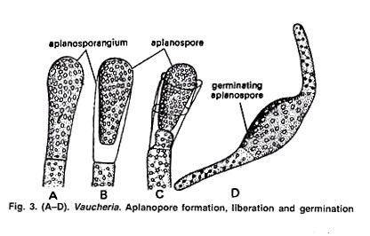
(c) By Akinetes:
Akinetes are thick walled structures formed during unfavorable conditions like drought, and low temperature. The akinetes have been commonly observed in V. geminata, V. megaspora and V. uncinata.
The akinetes are formed on the terminal part of lateral branches where protoplasm migrates to the tips followed by cross-wall formation (Fig. 4). These multinucleate, thick walled segments are called akinetes or hypnospores.
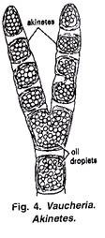
The akinetes by successive divisions may form numerous thin walled bodies called cysts. When many akinetes remain attached to the parent thallus, the thallus gives the appearance of another alga Gongrosira.
Hence this stage of Vaucheria is called Gongrosira stage. During favourable conditions the akinetes and cysts develop into new thalli. Randhawa (1939) has reported that in V. uncinata the submerged parts of thallus develop sex organs whereas exposed parts of thallus form brick shaped akinetes.

(iii) Sexual Reproduction in Vaucheria:
In Vaucheria sexual reproduction is of advanced oogamous type. The male and female sex organs are antheridia and oogonia, respectively.
Majority of the freshwater species are monoecious or homothallic while some species like V dichotoma, V. litorea and V. mayyanadensis are dioecious or heterothallic. There are different types of arrangement of antheridia and oogonia in homothallic species. The position, structure and shape of antheridia are of taxonomic importance in Vaucheria.
The common patterns of arrangement of sex organs are as follows:
(a) Antheridia and oogonia develop close to each other on the filament at intervals (Fig. 5 A-C).
(b) The antheridia and oogonia are borne on special side branches with a terminal antheridium and a number of lateral oogonia (Fig. 5D).
In V. hamata the reproductive branches bear a median terminal antheridium and two oogonia, one on either side of antheridium.
In V. geminata and V. terrestris the sex organs are produced at the ends of the lateral branches with a terminal antheridium and a group of oogonia (Fig. 5D). The sex organs are unilateral when they are arranged on one side of the filament or bilateral when they are on both sides of the filament.
(c) Antheridia and oogonia are borne on adjacent branches (Fig. 5E).
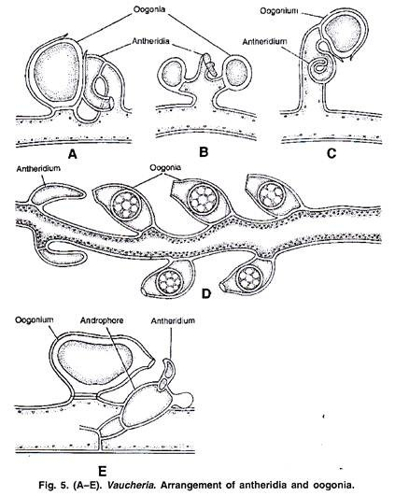
Structure and Development of Antheridium:
The mature antheridia may be cylindrical, tubular, straight or strongly curved. The antheridium is separated from main filament by a septum. The antheridia can be sessile (without stalk) arising directly from main branch e.g., V. civersa. The antheridia may be placed high on the branch the antheridia are situated on androphore V. synandra.
The young antheridium is usually green in colour. It contains cytoplasm, nuclei and chloroplasts. The mature antheridia are yellow and contain many spindle shaped antherozoids. The antherozoids are liberated through a terminal pore e.g., V. aversa or through many pores e.g., V. debaryana
In monoecious species the antheridium arises as a small bulging or lateral outgrowth along with or before the oogonium development (Fig. 6A). Many nuclei along with cytoplasm enter into it and it gets cut off from the lower part forming a septum.
The antheridium grows and becomes high curved structured, its upper part is main antheridium and the lower part is stalk. The nuclei of antheridium get surrounded by cytoplasm and develop into biflagellate, yellow coloured antherozoids The antherozoids are liberated from the tip of antheridium through apical pore shortly before day break (Fig. 6D-1).
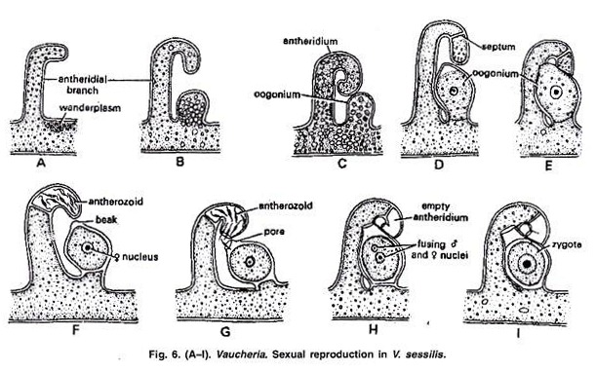
Structure and Development of Oogonium:
The oogonium development starts with accumulation of colourless multinucleate mass of cytoplasm near the base of antheridial branch. This accumulated cytoplasm has been termed as “wanderplasm”. The wanderplasm enters into the outgrowth or bulging of the main filament. This outgrowth is called as oogonial initial.
Large amount of cytoplasm and nuclei enter into oogonia, making it a large globular structure called as oogonium (Fig. 6 B-E). As the oogonium matures, it gets separated from main branch by the development of septum at its base. The mature oogonium is uninucleate structure. The nucleus of oogonium with protoplasm develops into a single egg.
There are three hypothesis regarding the fate of extra nuclei of oogonium of Vaucheria:
(a) According to Oltmanns (1895) accept a single nucleus which forms female nucleus, all other nuclei migrate back into the filament. This was supported by Heidinger (1908) and Couch (1932).
(b) According to Davis (1904), the single nucleus forms the egg and all other nuclei degenerate.
(c) According to Brehens (1890) all nuclei fuse to form a single nucleus.
The mature oogonia are globose, obovoid, hemispherical or pyriform in shape. The oogonia may be sessile or stalked structure. The protoplast of oogonium is separated from main filament by- septum formation.
The entire protoplasm with single nucleus makes a central spherical mass called as oosphere or ovum. In mature oogonium a distinct vertical or oblique beak develops in apical part. Opposite to beak develops a colourless receptive spot. A pore develops just opposite to receptive spot (Fig. 6 F).
Fertilization:
The oogonium secretes a gelatinous drop through a pore near the beak. A large number of liberated antherozoids stick to the drop. Many antherozoids push into the oogonium. The antherozoids strike violently, fall back and push forward again and fall back. Only one antherozoid enters into the oogonium.
After its entry the membrane develops at the pore to stop the further entry of antherozoids. The male nucleus increases in size and fuses with the egg nucleus to make diploid zygote. The zygote secretes a thick 3-7 layered wall and is now called as oospore (Fig. 6 G-I). The chromatophores degenerate and lie in the centre of the cell.
Germination of oospore:
The oospore undergoes a period of rest before germination. During favourable season the oogonial wall disintegrates and the oospore is liberated. The oospore germinates directly into new filaments.
Although the exact stage at which the reduction division takes place in Vaucheria is not clear, it is believed that reduction division occurs in first nuclear division in the germinating oospore (Fig. 7 A-D). The oospore germinates to make haploid thallus of Vaucheria.
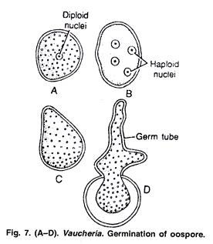

Life Cycle of Vaucheria:
According to Williams, Hanatsche and Gross the life cycle of Vaucheria is haplontic, the oospore being the only diploid structure in life cycle (Figs. 8, 9). Vaucheria thallus is haploid. It is aseptate, branched, tubular and coenocytic structure.
Vegetative re-production takes place by fragmentation. Asexual reproduction takes place by zoospore in aquatic species and by aplanospores in terrestrial species.
The zoospore is large multi flagellate structure and is supposed to be compound:
Zoospore or Synzoospore.
The sexual reproduction is advanced oogoinous type, the male and female sex organs are antheridia and oogonia. Most of the species are homothallic, some are heterothallic. After fertilization, a diploid zygote is formed which converts into oospore and undergoes a period of res The reduction division takes place in oospore during germination and an haploid thallus is formed (Fig. 8, 9).

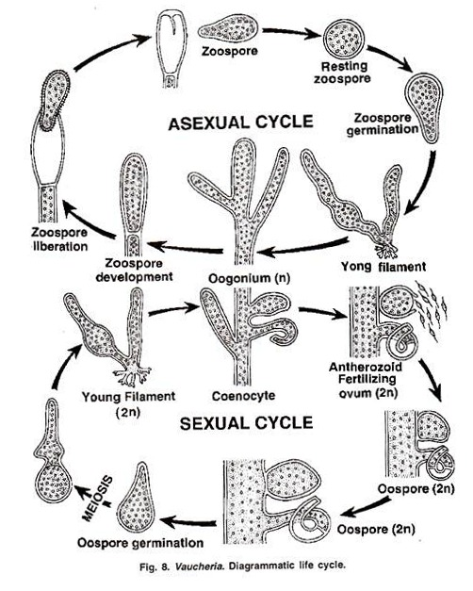
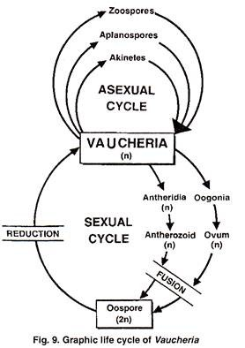

Batrachospermum Algae

Batrachospermum is a type of algae that grows in freshwater. It lives in transparent, cool, and fast-moving streams. Plants in deep water are dark violet or reddish in color. The shallow-water species, on the other hand, are olive green. The color of pigments is affected by the strength of light. The substratum is bound to the thallus.

Batrachospermum Classification:
Division: Rhodophyta
Class: Florideophyceae
Order: Batrachospermales
Family: Batrachospermaceae
I
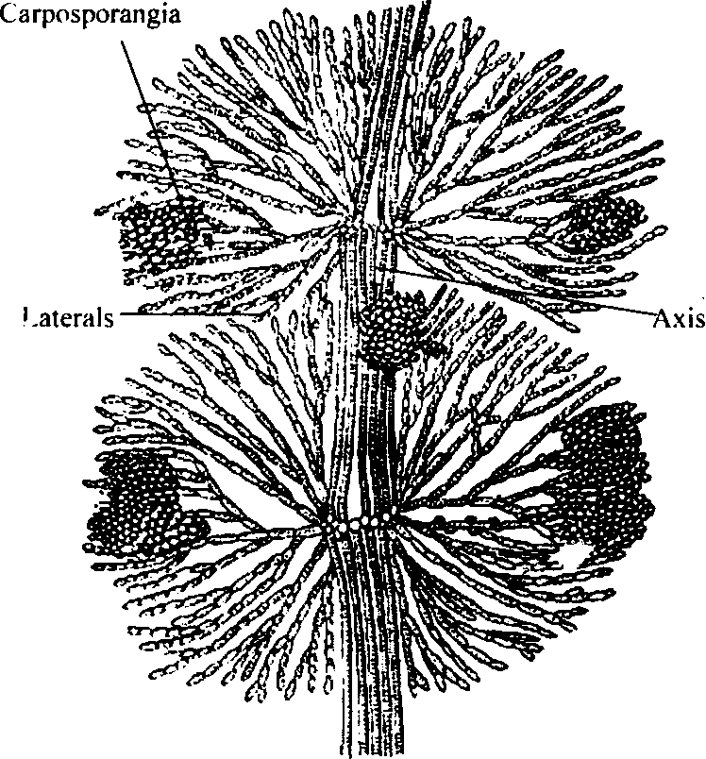

Occurrence:
That's one of the freshwater Rhodophyceae species. This alga can be found in slow-moving streams, as well as along the shores of lakes and ponds. It's more common in well-oxygenated waters. Colors include blue-green, olive-green, violet, and reddish. Because of the variations in light intensity, the color changes. The species that develop in deep water appear reddish or violet in color, while those that grow in shallow water are olive-green. Frogspawn is another name for the alga. To the naked eye, the plants look mucilaginous, moniliform, or beaded.

General Structure:

Vegetative Structure
The adult plant's thallus is soft, dense, and filamentous. It has a lot of branches and is gelatinous. A single row of broad cells makes up the central axis. Upon that axis, whorls of branches with limited growth evolve. These filamentous, dichotomously arranged branches are filamentous. The main axis has a corticated appearance. A series of elongated cylindrical cells make up this structure. It is divided into two categories: nodes and internodes.

From the nodes, there are two groups of branches:
- Branches of Limited Growth: These emerge in whorls from the nodes. Such branches grow for a while before becoming long hairs. Their cells were arranged in a bead-like pattern. A whorl's branches were of the same length. As a result, they form globos structure glomerulus.
- Branches of Unlimited Growth: Such branches develop from the imsal cells of limited-growth branches. These are often corticated and divided into nodes and internodes. From their nodes, branches of minimal growth emerge. Their cells become longer in comparison.
The cells have no nuclei. Two-layered cell walls keep their cells in check. The outer layer is made up of pectic compounds, while the inner layer is made up of cellulose. Within cells, pit connections exist. There are several irregular chromatophores in a cell. Phorerythrin, phycocyanin, and some other photosynthetic pigments such as chlorophyll-a, Carotene, chlorophyll b, and Xanthophyll are among its pigments. A single pyrenoid is present in each chromatophore. The axis' central cells are linked by cytoplasmic connections. Floedean starch is a food ingredient that has been set aside.

Growth:
- Limited-growth branches are formed as a single cell at the apex of the main clament grows. The cell undergoes transverse division. It hacked away at cells on the backside. Four small cells are cut off by each of these cells. The initials of these cells become the side branches' initials. Such kind initials are divided numerous times. These lateral cell groups produce a coster of small branches. It creates a beaded pattern on the vine. A glomerulus is a group of side branches. Whorls are formed by these branches.
- Central Axis Cell Elongation: The central axis cell elongates dramatically. As a result, lateral cells begin to differentiate from one another. As a result, on the axis, they create a node-like structure.
- Formation of Pseudocortex: Filaments are generated by the cells at the nodes as they move downward. They encircle the central cells before they reach the next node. As a result, a loose covering forms around the central axis. Pseudocortex is the term for this loose coating.
- Formation of Unrestricted-growth Branches: Apical cells may be one or more cells on each node. Like the main axis, this cell develops lateral branches with infinite growth potential.

Batrachospermum Reproduction:
- Asexual Reproduction: Batrachospermum produces monospores, which are non-motile asexual spores. Only the juvenile or chantransia stage produces them.
- Sexual Reproduction: Oogamy is a form of sexual reproduction. It's possible that the plant is both homothallic and heterothallic.
- Antheridia or Spermatangia: Antheridia or spermatangia are the male sex organs. They are a single-celled structure. The mature spermataguium has a thick wall, is colorless, and has a rounded shape. Spermatangia are made singly, in pairs, and in four-person groups. Antheridium protoplast transforms into just a single non-motile spermatium. The antheridial wall fractures, allowing sperm to escape.
- Carpogonia: Carpogonia is the female reproductive organ. Carpogonia is a single-celled organism. It is made up of an elongated cell that is present at the base. Trichogyne refers to the larger upper section. Mirophore refers to the lower globular part. Ascocarp refers to the branch that bears the carpogonium. The ascocarp is made up of four cells. Carpogonium is formed by the terminal cell. Mirophore contains the nucleus of an egg. The nucleus of an egg is enclosed by cytoplasm and transforms into an egg. A constriction separates trichogyne from the mirophore. Trichogyne is a sperm-receiving organ.

Batrachospermum Life Cycle:
The spermatia that are not motile float in the water. The trichogyne is approached by a large number of spermatia. The trichogyne is attached to one of the spermatia. The contact wall dissolves, and one of the spermatium's two nuclei flows via this hole into the trichogyne, fusing with the female egg and developing into the zygote within the basal swollen region of the carpogonium. The trichogyne then shrivels down until it reaches the constriction between trichogyne and carpogonium. At the same time, a cross wall forms at this stage.

Germination of the Zygote: The zygote's diploid nucleus separates meiotically, yielding two haploid nuclei. After that, one of the two nuclei travels into the zygote's lateral protrusion. This protrusion is separated from the rest of the zygote by a wall, and the gonimoblast initial is shaped in this way. The other daughter nucleus divides many times, resulting in a large number of gonimoblast initials. The gonimoblast branches out, and the terminal cells of such branched gonimoblast grow into carposporangia. Each carposporangium generates a unique single haploid carpospore that is rounded. The cystocarp or carposporophyte is a structure of gonimoblast filaments, carposporangia, and carpospores.

FUCUS

Fucus is a brown algae genus that can be found in the intertidal zones of rocky seashores all over the world. Some species of Fucus are fucus crispus, fucus serratus etc.
Just like fucus laminaria is another genus of brown seaweed in the order Laminariales(Kelp) that comprises 31 native species of the North Atlantic and northern pacific ocean.
Along with Fucus Kelps are also brown algae seaweeds that make up the order Laminariales which consists of 30 different genera. Kelp is a heterokont, not a plant, despite its appearance.

Fucus Algae Classification
- Clade: SAR
- Phylum: Ochrophyta
- Class: Phaeophyceae
- Order: Fucales
- Family: Fucaceae
- Genus: Fucus
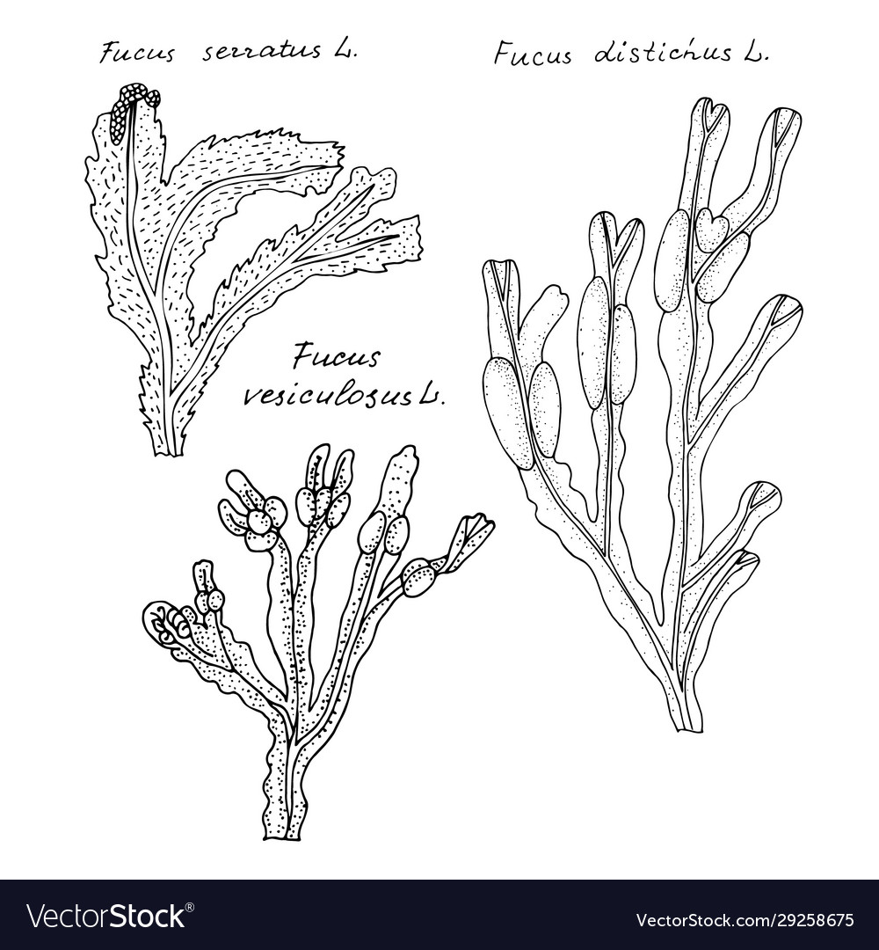

Fucus Algae Description and Life Cycle
Description:
- With an uneven or disc-shaped holdfast or haptera, the thallus is perpetual. The thallus is dichotomous or sub-pinnately branched, flattened, and has a prominent midrib on the upright section.
- Some species have pairs of gas-filled pneumatocysts (air-vesicles), one on each side of the midrib. Cryptostomata and caecostomata are found on the thallus's erect part (sterile surface cavities).
- Because of abrasion of the tissue lateral to the midrib, the thallus' base is stipe-like, and it is held to the rock by a holdfast.
- In the apices of the terminal branches, the gametangia develop in conceptacles implanted in receptacles. It's possible that they're monoecious or dioecious.

Life Cycle:
- These algae have a straightforward life cycle and only generate one type of thallus, which can reach a maximum size of 2 metres.
- The reproductive cells are contained in fertile holes called conceptacles, which are immersed in the receptacles toward the ends of the branches.
- Following meiosis, the female and male reproductive organs, oogonia and antheridia, generate egg cells and sperm, which are discharged into the water and fertilised.
- The zygote that results develops into a diploid plant.
- This is in contrast to the flowering plant's life cycle, in which the egg cells and sperm are created by a haploid multicellular generation, though at a far reduced level, and the egg cells are fertilised within the parent plant's ovules before being released as seeds.

About Alga Fucus Vesiculosus
Bladderwrack, black tang, rockweed, bladder fucus, sea oak, cut weed, dyers fucus, red fucus, and rock wrack are all popular names for Fucus vesiculosus, a seaweed found along the coastlines of the North Sea, the western Baltic Sea, and the Atlantic and Pacific Oceans. It was the first source of iodine, discovered in 1811, and was widely used to treat goitre, a thyroid gland enlargement caused by a lack of iodine.

Classification:
- Clade: SAR
- Phylum: Ochrophyta
- Class: Phaeophyceae
- Order: Fucales
- Family: Fucaceae
- Genus: Fucus
- Species: F. vesiculosus

Vesiculosus Fucus Description:
- Fucus vesiculosus fronds reach 90 cm (35 in) in length and 2.5 cm (1.0 in) in width, with a pronounced midrib throughout.
- A basal disc-shaped holdfast secures it. It features virtually spherical air bladders that are generally paired on either side of the mid-rib, but young plants may lack them.
- The frond is dichotomously branched and has a smooth edge.
- It's sometimes mistaken for Fucus spiralis, with which it hybridises, and it's related to Fucus serratus.

Life Cycle:
- Fucus vesiculosus plants are dioecious.
- In most cases, gametes are released into calm seawater, and the eggs are fertilised externally to generate a zygote.
- Shortly after being released from the container, the eggs are fertilised.
- Research on the Maine coast found that both exposed and protected areas had 100% fertilisation. In the Baltic Sea, populations that are constantly submerged are extremely susceptible to stormy conditions.
- Because the gametes are only released when water velocities are low, high fertilisation success is attained.

Uses and Adverse Effects:
- Fucus vesiculosus is marketed as a dietary supplement.
- Mucilage, algin, mannitol, fucitol, beta-carotene, zeaxanthin, volatile oils, iodine, bromine, potassium, and other minerals are among the primary chemical ingredients.
- Fucus vesiculosus consumption can produce platelet inhibition, which can increase the anticoagulant effect of warfarin (Coumadin). It is best to avoid it prior to surgery.
- The iodine in Fucus vesiculosus may cause allergic reactions in certain persons.

Fucus Serratus
Fucus serratus, often known as toothed wrack or serrated wrack, is a North Atlantic seaweed.

Classification:
- Clade: SAR
- Phylum: Ochrophyta
- Class: Phaeophyceae
- Order: Fucales
- Family: Fucaceae
- Genus: Fucus
- Species: F. serratus

Description and Reproduction:
- Fucus serratus is a strong alga that looks like Fucus vesiculosus and Fucus spiralis and is olive-brown in colour.
- It grows up to 180 centimetres (6 feet) long from a discoid holdfast.
- Flat, bifurcating, and up to 1 m (3 ft 3 in) long, including a small stipe, the fronds are about 2 cm (0.8 in) wide, bifurcating, and up to 1 m (3 ft 3 in) long. It has uneven and dichotomous branches.
- The flattened blade has a pronounced midrib and the serrated edge of the fronds distinguishes it from related taxa.
- It doesn't have air vesicles like Fucus vesiculosus, and it's also not spirally twisted like F. spiralis.
- Plants with male and female receptacles are found on separate plants.
- Cryptostomata — tiny cavities that produce colourless hyaluronic acid – can be seen on the lamina.
- Conceptacles, which are submerged in receptacles near the branch terminals, form the reproductive bodies.
- Oogonia and antheridia are generated in these conceptacles, and after meiosis, the oogonia and antheridia are discharged.
- The zygote develops, settles, and grows immediately into the diploid sporophyte plant after fertilisation.

FAQ (Frequently Asked Questions)
1. Which Pigment is Responsible for the Brown Colour in Fucus?
Ans) Fucoxanthin, a pigment found in most brown algae, is responsible for the greenish-brown colour that gives them their name. Apart from this, Chlorophyll a and c are also present in Fucus.
2. Why are Algae Considered Plant-Like?
Ans) The primary reason for this is that they contain chloroplasts, which make food via photosynthesis. However, they lack many other plant-like structures. Algae, for example, have no roots, stems, or leaves.
3. Are All Alga Seaweeds?
Ans) Seaweeds are a type of algae with a few unique traits. For example, all seaweed species are autotrophic, whereas some algal species rely on other sources of nourishment. Algae can be found in both freshwater and marine environments, whereas seaweeds can only be found in seawater.

